**Lab Experiment: 01**

**Experiment Name: Smart Quantization Technique of an Analogue Signal**

**Objective:** Objective of this experiment to introduce with sampling and quantization of an analogue signal, and conversion of a signal from analogue to digital.

**Basic Theory:** Quantization, in mathematics and digital signal processing, is the process of mapping a large set of input values to a (countable) smaller set. Rounding and truncation are typical examples of quantization processes.  A device or algorithmic function that performs quantization is called a quantizer. An analog-to-digital converter is an example of a quantizer.

**Steps to Follow:**

* **Filtering**
* **Sampling**
* **Encoding**

**Experiments and Results:**

**Task1: Design a quantizer to quantize sampled signal:**

S= [-2.7, -1.6, 1.2, 1.4, 2.8, 3.9, 4.2]

for the range, [3,inf]=3.5, [1,3]=2, [0,1]=0.5, and [-inf,0]=-1.

%Matlab Code

partition = [0,1,3];

quantization = [-1,0.5,2,3.5];

S=[-2.7,-1.6,-1.2,1.4,2.8,3.9,4.2]; %sampled signal

[I,Q]=quantiz(S,partition,quatization);

%Q gives the quantized value

stem(S)

hold on

stem(Q,'>r')

grid on

S

Q

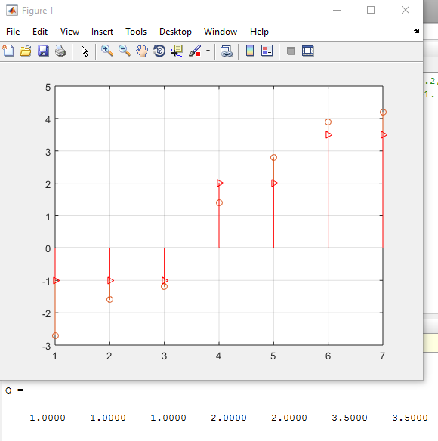

**Task 2: Design a quantizer to quantize sampled signal:**

S=[-0.7,1.6,1.2,3.4,3.1,3.9,4.2] for the following partition and

quantization levels. Also find PCM.

%Matlab Code

partition = [1.5,2.5,3.5];

quantization = [1,2,3,4];

S = [-0.7, 1.6, 1.2, 3.4, 3.1, 3.9, 4.2]; %sampled signal

[I,Q] = quantiz(S, partition, quantization);

%Q gives the quantize vale

Q

dec2bin(Q) %Decimal to binary i.e., PCM

**Output:**

**Q = 1 2 1 3 3 4 4**

**Answer = 001 011 011 100 100**

**Task 3: Do the same job for a sinusoidal wave and plot the results**

% Matlab code

t=0:0.1:2*pi;

S=4*sin(pi*t); %sampled signal

partition = [-3,-2,-1,0,1,2,2.5,3.5];

quantization = [-3.5,-3,-2,-1,0,1,2,3,3.5];

[I,Q]=quantiz(S,partition,quantization); %Q gives quantized value

plot(t,S,'k',t,Q,'*k')

xlabel('time')

ylabel('Amplitude')

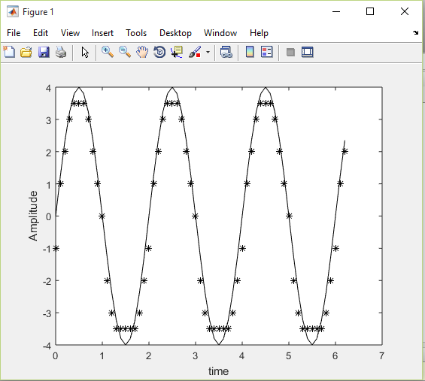

**Task 4:** Determine the maximum error and standard deviation of error; hence plot error versus time.

% Matlab code

t=0:0.01:2*pi;

S=4*sin(pi*t); %sampled signal

partition = [-3,-2,-1,0,1,2,2.5,3.5];

quantization = [-3.5,-3,-2,-1,0,1,2,3,3.5];

[I,Q]=quantiz(S,partition,quantization);

%Q gives quantized value

SD = sqrt(sum((Q-S).^2)/length(Q))

%Standard deviation of Q and S

E=max(abs(Q-S)) %maximum value of error

Er=S-Q;

plot(t,Er,'k')

xlabel('time')

ylabel('Error')

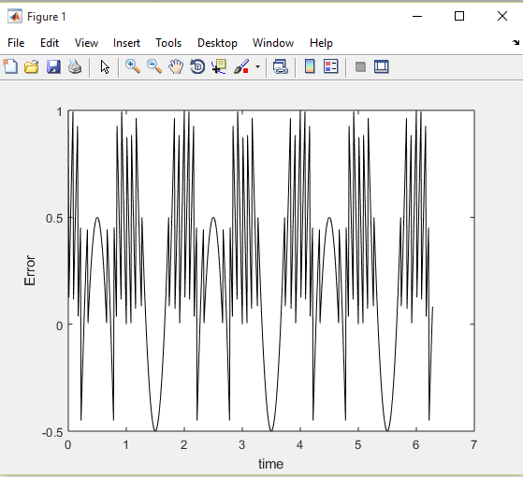

**SD = 0.4579 E = 1**

**Following code shows the quantization of speech signal and the corresponding result is shown in figure.**

% Matlab code

load mtlb

S=mtlb;

partition=[-3,-2,-1,0,1,2,2.5,3.5];

quantization=[-3.5,-3,-2,-1,0,1,2,3,3.5];

[I,Q]=quantiz(S, partition, quantization);

plot(Q,'k')

hold on

plot(S,'g')

xlabel('Time in number of samples')

ylabel('Amplitude')

